New Restaurant in Bengaluru, India

# Coursera DS Capstone Project

# Introduction/ Business Problem

Choosing a restaurant site can be quite tricky and the location plays a critical factor in the success of a restaurant. There are multiple variables involved including proximity to entertainment centers, public transport systems, market places, target customers, competing and complimenting restaurants, restaurant density in the area etc.

Also, we can gauge the social culture of the city by comparing it to other similar cities. Get to know the preferences of the society in terms of the food they relish. Here, I will try to analyze a major IT hub in India – Bengaluru (earlier Bangalore) and try to answer the below questions -

1. Comparing neighborhoods of New York and Bengaluru to gauge how similar/dissimilar they are.
2. Analyzing the locality of Bengaluru to decide which area is more suited to open a new restaurant.

# Data Description

List of Neighborhoods in Bangalore - <https://en.wikipedia.org/wiki/List_of_neighbourhoods_in_Bangalore>

* 1. Neighbourhood Names (Total = 63)

Location coordinates for each neighbourhood scraping through their Wikipedia pages iteratively

* 1. Neighborhood Names
  2. Latitude
  3. Longitude

Foursquare API to explore all Bengaluru neighbourhoods

* 1. Neighborhood Names
  2. Latitude
  3. Longitude
  4. Venues Nearby
  5. Venue Latitude
  6. Venue Longitude
  7. Venue Category

# Methodology

Exploratory Analysis –

Bar chart of ‘Number of venues received from Foursquare API for each neighbourhood’. As can be seen, Indiranagar (43) has the highest number of venues, followed by HSR Layout (37) and Kalyan Nagar (33).

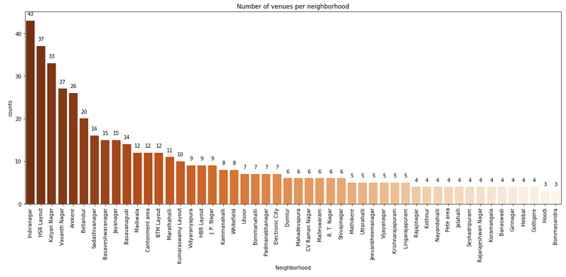

Bar chart of ‘Frequency of various venue categories amongst 518 venues received from Foursquare API’. Indian Restaurant (103) is the highest venue category amongst all venues. There is a huge drop afterwards with Café (28) and Fast Food (22) being 2nd and 3rd most common venue categories.

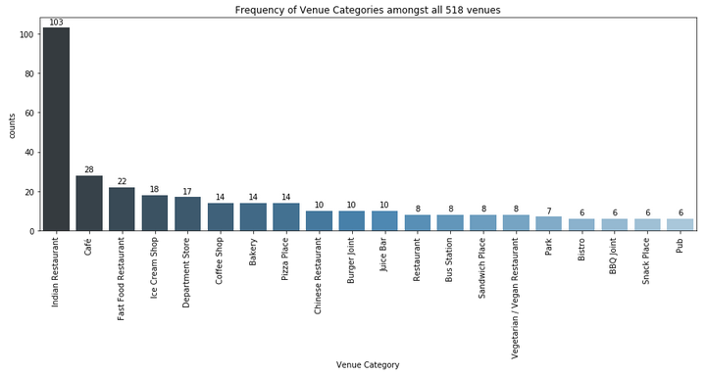

Machine Learning –

K Means clustering was performed to identify Bengaluru neighbourhoods which are similar to each other. The number of clusters is 5. The clusters received were then compared to those of New York (from lab notebook) to gauge the differences between the two cities.

New York Most Visited Venues

Bengaluru Most Visited Venues

* Coffee shop
* Cocktail bar
* Park
* Italian Restaurant
* Yoga Studio
* Gym
* French Restaurant
* Indian Restaurant
* Café Shops
* Department Store
* Pizza Place
* Desert Shop
* Fast food restaurant
* Bakery

# Results

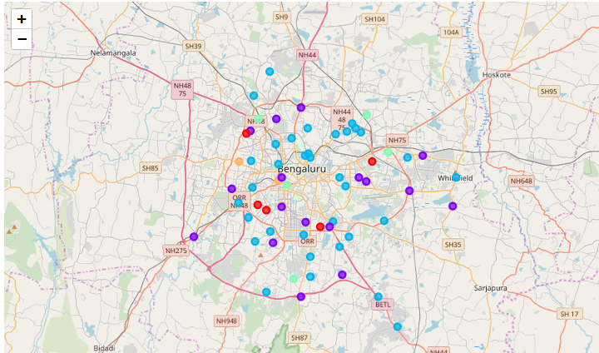

63 neighborhoods were grouped into 5 clusters –

* Cluster 2 (Deep Green) lies on the outer ring road periphery of Bengaluru. It depicts the new Bengaluru areas which do contain many Indian restaurants but have considerable higher %age of Café, Ice Cream shops and Pizza places compared to other clusters.
* Cluster 0 (Red) is concentrated towards the West/South West Bengaluru. It depicts the old Bengaluru areas and are high on Indian restaurants mainly, followed by Fast food and Bakery shops.
* Cluster 1 (Violet) is distributed all over Bengaluru.
* Cluster 3 (Light Green) and Cluster 4 (Yellow) are very small.

# Discussion

Observations –

As can be seen, the cities of Bengaluru and New York (lab notebook) are quite different. The most common venues in Bengaluru includes - Indian Restaurant, Cafe Shops, Department Stores, Pizza place, Desert shop, Fast food restaurants, and Bakery.

Whereas, in New York, the most visited places are - Coffee shop, Cocktail bar, Park, Italian restaurant, Yoga studio, Gym and French Restaurant.

Recommendations –

Hence, in case of restaurants, it makes sense to open either 'Indian Restaurant' or 'Pizza Place' or ‘Cafe Shop' in Bengaluru, India.

Let’s assume that the restaurant to be opened is a 'Pizza Place'. Hence, further location analysis is required to decide the neighbourhood. Here, those neighbourhoods are to be selected where Pizza shops are amongst the top 3 most common venues.

# Conclusion

Amongst neighbourhoods - Domlur, CV Raman Nagar, Vidyaranyapura, BTM Layout, Arekere - are the locations wherein 'Pizza Place' is amongst the top 3 most common venue. Out of these 5 places, only CV Raman Nagar and BTM Layout are located nearby metro stations.

BTM Layout seems a better choice compared to CV Raman Nagar because of two other factors.

First, BTM layout is more popular commercial and residential area of Bangalore.

Second, as can be inferred from the most common venues list, more restaurants are visited in BTM layout (in the top 10 venues) compared to CV Raman Nagar.

Hence, the final choice of neighbourhood for opening a Pizza restaurant should be 'BTM Layout'.